

Mobile Application Store Authentication Service

DESIGN DOCUMENT



November 22, 2013

Fanxing Meng

Reviewer: Jayaprakash Ganta

Table of Contents

Introduction 2

Overview 2

Requirements 2

Use Cases 2

Sequence Diagram 4

Activity Diagram 6

Implementation 7

Class Diagram 7

Class Dictionary 8

AccessDeniedException 8

Authentication 8

AuthenticationException 11

AuthenticationImporter 11

Creator 11

Entitlement 12

EntitlementData 12

ImportException 13

InvalidAccessTokenException 14

Permission 14

PermissionIterator 15

PrintVisitor 15

Role 15

RoleIterator 16

Service 17

ServiceData 17

Token 18

TokenData 19

User 19

UserData 20

Visitable 21

Visitor 21

Implementation Details 22

Testing 22

# Introduction

This document defines the design for the Mobile Application Store Authentication Service. Mobile application stores provide contents including applications, ringtones and wallpaper for mobile device users. Authentication service enables administrators to set permission to different categories of users to ensure store content safety against unauthorized stack.

# Overview

In this phase we have developed the authentication service of the app store. The authentication service allows administrators to define services, permissions for each restricted operation, roles that users could assign to, users and their credentials, and manage entitlement among roles and users. The authentication service starts with only an admin user having root privilege. The administrator must first log on to this user to set up necessary permissions and authentication_admin users. After which he/she should change the admin password and log on to a regular (specific) admin account using user name and password to manage the services available. For each login, the user receives a token; he/she should pass the token as an argument to access restricted functions. If the user does not have the necessary permission, he/she would get an exception specific to the request.

# Requirements

The functional requirements are that only an authentication administrator is able to create services with that aggregates a set of permissions; the admin can create permissions for each restricted function within a service; he/she creates roles that are composites of permissions and roles, and assign them to users, which the admin also has to create. Any registered users may log in the system using user name and password and receive a token for future authentication in the current session if log in succeeds; the token has a certain expiration time to remain active. Upon logout, the assigned token becomes invalid. To ensure restricted access among all services, each of these restricted functions should validate a passes token in authentication service to check for required permission.

The structural requirements are: Service, Permission, and Role all have fields ID, name, and description; Service contains Product API, Collection Service, and Authentication Service; A Service may have one or more permissions while a User may have zero or more permissions or roles; A User has an ID, name, and a set of credentials, each contains a user name and a hashed password; A Token has an ID, expiration time, and a state; it binds a User to a set of Permissions.

# Use Cases

Current design supports the following use cases:

The root user has all available permissions. All users and administrators can log in, log out, and search collections and products.

Among all restricted functions, the authentication admin has permission to the seven functions affiliated with authentication service (also the authentication admin role) at the top of the diagram; collection admin can create collection, add content to static collection and set search criteria for dynamic collection; product admin can create country and devices; finally product developer can create product.

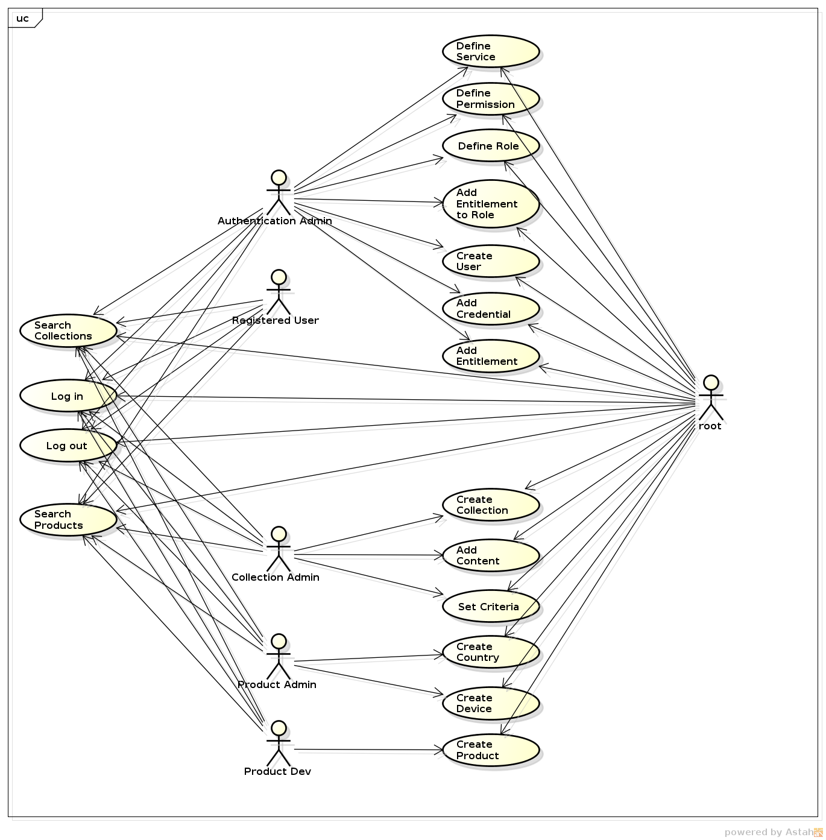

# Sequence Diagram

Each class will cooperate with other classes as shown below:

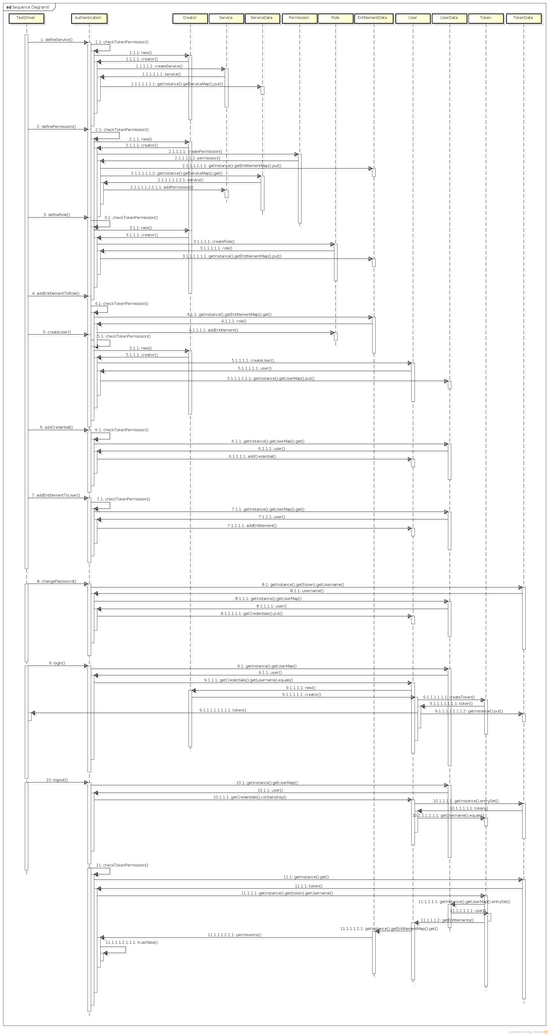



# Activity Diagram

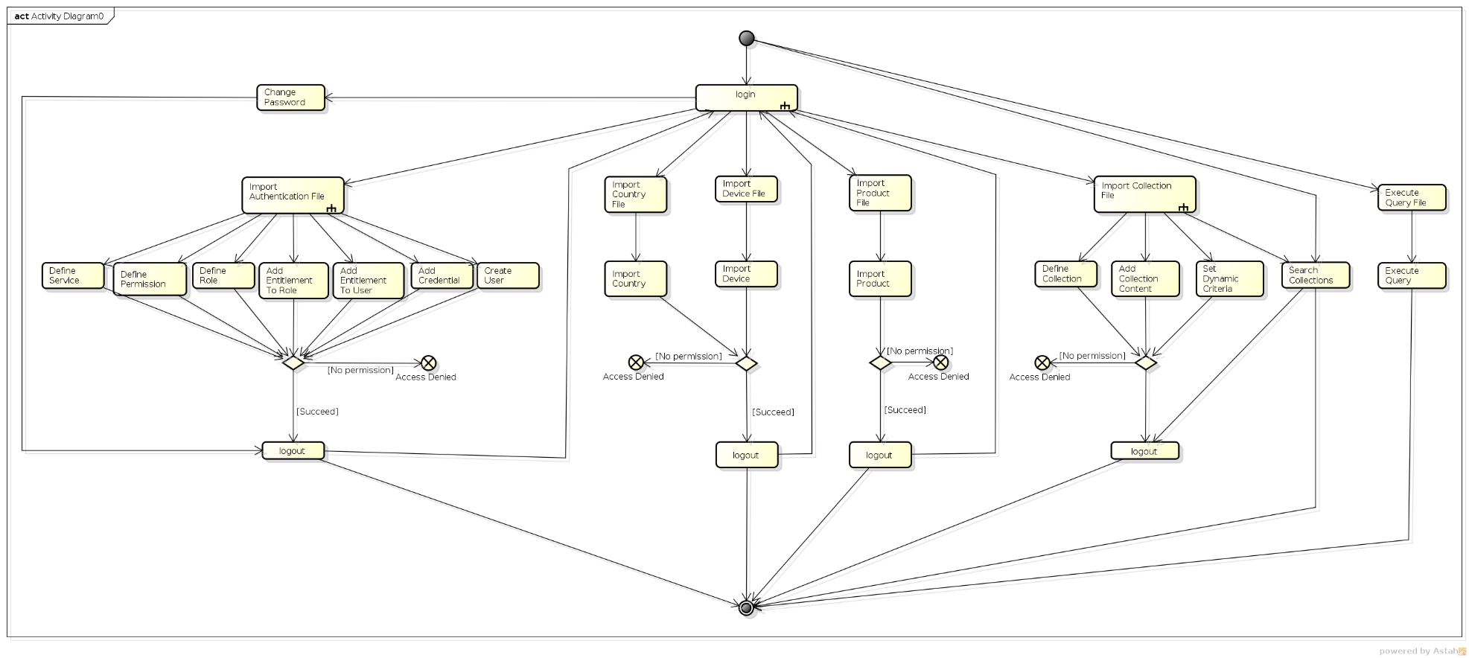

# Implementation

## Class Diagram

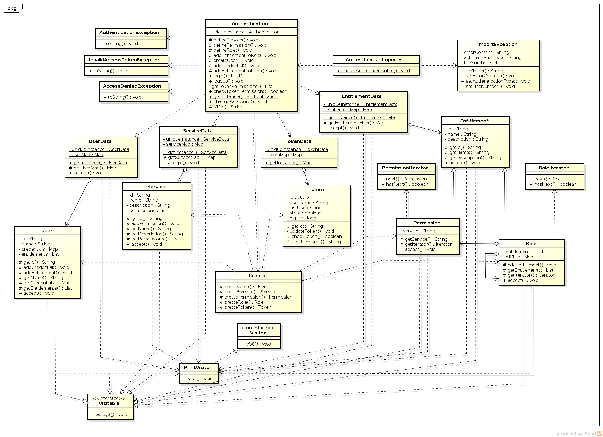

## Class Dictionary

This section specifies the class dictionary for the authentication service. The classes are defined within the package “cscie97.asn4.ecommerce.authentication”.

### AccessDeniedException

The AccessDeniedException class provides exception to handle situations where a username/password is invalid or missing

#### Methods

|  |  |  |
| --- | --- | --- |
| Method Name | Signature | Description |
| toString | (void):void | Public method for formatting the output information of this type of exception as "Access Denied: message" |

### Authentication

The Authentication class provides an instance of the authentication service with functions necessary to create, manage, and test all authentication functions.

#### Methods

|  |  |  |
| --- | --- | --- |
| Method Name | Signature | Description |
| getInstance | (void):Authentication | Public method for getting the unique instance of the authentication service. |
| defineService | (newId:String, newName:String, newDescription:String, token:UUID, permission:String):void | Protected method for defining a service. Checks for token permission and duplicate service ID. Throws AuthenticationException on duplicate ID and InvalidAccessTokenException on token not having correct permission. |
| definePermission | (serviceId:String, permissionId:String, newName:String, newDescription:String, token:UUID, permission:String):void | Protected method for defining a permission. Checks for token permission, duplicate permission ID, and invalid service ID. Throws AuthenticationException on duplicate or invalid ID and InvalidAccessTokenException on token not having correct permission. |
| defineRole | (newId:String, newName:String, newDescription:String, token:UUID, permission:String):void | Protected method for defining a role. Checks for token permission and duplicate role ID. Throws AuthenticationException on duplicate ID and InvalidAccessTokenException on token not having correct permission. |
| addEntitlementToRole | (roleId:String, entitlementId:String, token:UUID, permission:String):void | Protected method for adding an entitlement to role. Checks for token permission, duplicate/invalid entitlement ID, and invalid role ID. Throws AuthenticationException on duplicate or invalid ID and InvalidAccessTokenException on token not having correct permission. |
| createUser | (newId:String, newName:String, token:UUID, permission:String):void | Protected method for creating a user. Checks for token permission and duplicate user ID. Throws AuthenticationException on duplicate ID and InvalidAccessTokenException on token not having correct permission. |
| addCredential | (userId:String, newName:String, newPassword:String, token:UUID, permission:String):void | Protected method for adding credential to a user. Checks for token permission, duplicate user name, and invalid user ID. Throws AuthenticationException on duplicate or invalid ID and InvalidAccessTokenException on token not having correct permission. |
| changePassword | (token:UUID, password:String):void | Public method for changing a user’s password. Checks for token existence and validity. Throws AccessDeniedException on non-existing token and InvalidAccessTokenException on expired token. |
| addEntitlementToUser | (userId:String, entitlementId:String, token:UUID, permission:String):void | Protected method for adding an entitlement to a user. Checks for token permission, duplicate/invalid entitlement ID, and invalid user ID. Throws AuthenticationException on duplicate or invalid ID and InvalidAccessTokenException on token not having correct permission. |
| login | (username:String, password:String):UUID | Public method for logging in. Checks for user name existence and password validity. Throws AccessDeniedException for either false. |
| logout | (username:String):void | Public method for logging out. Checks for user name existence. Throws AccessDeniedException for non-existing user name. |
| getTokenPermissions | (token:UUID):List<String> | Private method for getting token’s permissions. Returns empty list if there’s no permission associated with it. |
| checkTokenPermission | (token:UUID, permission:String):Boolean | Public method for checking token against a permission. Checks for token existence and validity. Throws AccessDeniedExceptionon non-existing token and InvalidAccessTokenException on expired token. |
| MD5 | (md5:String):String | Protected method for computing MD5 value from a string. Throws NoSuchAlgorithmException on error. |

#### Properties

|  |  |  |
| --- | --- | --- |
| Property Name | Type | Description |
| uniqueInstance | Authentication | Private field maintaining the unique instance of the authentication service. |

### AuthenticationException

The AuthenticationExceptionclass provides exception to handle situations where a field is invalid or missing.

#### Methods

|  |  |  |
| --- | --- | --- |
| Method Name | Signature | Description |
| toString | (void):void | Public method for formatting the output information of this type of exception as " Authentication Exception: message" |

### AuthenticationImporter

The importer is responsible for reading authentication information from .csv file. The importer calls authentication functions to dispatch operation on each line of code.

#### Methods

|  |  |  |
| --- | --- | --- |
| Method Name | Signature | Description |
| importAuthenticationFile | (filename:String, token:UUID):void | Public method for reading authentication information from .csv file line by line and calls functions in Authentication class to import data. Checks for operation type and argument number. Throws ImportException on error parsing the file. |

### Creator

The creator is responsible for creating service, user, permission, role, and token objects.

#### Methods

|  |  |  |
| --- | --- | --- |
| Method Name | Signature | Description |
| createService | (newId:String, newName:String, newDescription:String):Service | Protected method for creating a service. |
| createUser | (newId:String, newName:String):User | Protected method for creating a user. |
| createPermission | (newId:String, newName:String, newDescription:String, newServicen:String): Permission | Protected method for creating a permission. |
| createRole | (newId:String, newName:String, newDescription:String):Role | Protected method for creating a role. |
| createToken | (newId:UUID, newName:String, time:long):Token | Protected method for creating a token. |

### Entitlement

The Entitlement abstract class implements the Visitable interface and provides the fields and methods that are common to both roles and permissions.

#### Methods

|  |  |  |
| --- | --- | --- |
| Method Name | Signature | Description |
| getId | (void):String | Protected method for returning the entitlement ID. |
| getName | (void):String | Protected method for returning the entitlement name. |
| getDescription | (void):String | Protected method for returning the entitlement description. |
| getIterator | Iterator | Protected method for getting a recursive iterator of entitlements. |
| accept | (visitor:Visitor):void | Public method for accepting a visitor to the entitlement. |

#### Properties

|  |  |  |
| --- | --- | --- |
| Property Name | Type | Description |
| id | String | Protected id field for the entitlement. |
| name | String | Protected name field for the entitlement. |
| description | String | Protected description field for the entitlement. |

### EntitlementData

The EntitlementData class implements the Visitable interface and provides an aggregation of Entitlement objects enabling visitors to traverse, initialized with root permission and role.

#### Methods

|  |  |  |
| --- | --- | --- |
| Method Name | Signature | Description |
| getInstance | (void):EntitlementData | Public method for getting the unique instance of the EntitlementData class. |
| getEntitlementMap | (void): Map<String, Entitlement> | Protected method for getting the entitlement map of the EntitlementData class. |
| accept | (visitor:Visitor):void | Public method for letting the visitor traverse through the entire entitlement map. |

#### Associations

|  |  |  |
| --- | --- | --- |
| Association Name | Type | Description |
| entitlementMap | Map<String, Entitlement> | Private association for listing all created entitlements. |

#### Properties

|  |  |  |
| --- | --- | --- |
| Property Name | Type | Description |
| uniqueInstance | EntitlementData | Private unique instance of the EntitlementData class. |

### ImportException

The ImportExceptionclass provides exception to handle situations where there is an error in the input authentication file.

#### Methods

|  |  |  |
| --- | --- | --- |
| Method Name | Signature | Description |
| toString | (void):String | Public method that formats the output information of this type of exception as “error importing authentication type: authenticationType at line number lineNumber with error errorContent” |
| setErrorContent | (errorContent:String):void | Public method that sets the error content using passed-in argument. |
| setAuthenticationType | (authenticationType:String):void | Public method that sets the authentication type using passed-in argument. |
| setLineNumber | (lineNumber:int):void | Public method that sets the line number using passed-in argument. |

#### Properties

|  |  |  |
| --- | --- | --- |
| Property Name | Type | Description |
| errorContent | String | Private content field for the error. |
| authenticationType | String | Private type field for the authentication exception. |
| lineNumber | int | Private line number field storing where the error occurred. |

### InvalidAccessTokenException

The InvalidAccessTokenExceptionclass provides exception to handle situations where the token is invalid for a certain permission.

#### Methods

|  |  |  |
| --- | --- | --- |
| Method Name | Signature | Description |
| toString | (void):void | Formats the output information of this type of exception as " Invalid access token for: message" |

#### Properties

|  |  |  |
| --- | --- | --- |
| Property Name | Type | Description |
| errorContent | String | Private content field for the error. |

### Permission

The Permission class implements the Visitable interface and provides the fields and methods for permissions.

#### Methods

|  |  |  |
| --- | --- | --- |
| Method Name | Signature | Description |
| getService | (void):String | Protected method for getting the service ID associated with the permission. |
| getIterator | Iterator | Protected method for getting a null iterator of permission. |

#### Properties

|  |  |  |
| --- | --- | --- |
| Property Name | Type | Description |
| service | String | Private service id field for the permission. |

### PermissionIterator

The Class PermissionIterator that implements java’s iterator but returns null and false for permissions as they are the end of the entitlement tree.

#### Methods

|  |  |  |
| --- | --- | --- |
| Method Name | Signature | Description |
| hasNext | (void):boolean | Public method for checking whether there is a next element at the end of entitlement tree, which is false. |
| next | (void):Object | Public method for getting the next element at the end of entitlement tree, which has none. |
| remove() | (void):void | Not supported. |

### PrintVisitor

The PrintVisitor class implements Visitor interface and prints out one message for each object it visits.

#### Methods

|  |  |  |
| --- | --- | --- |
| Method Name | Signature | Description |
| visit | (user:User):void | Public method for visiting a user. |
| visit | (permission:Permission):void | Public method for visiting a permission. |
| visit | (role:Role):void | Public method for visiting a role. |
| visit | (service:Service):void | Public method for visiting a service. |
| visit | (entitlement:Entitlement):void | Public method for visiting an entitlement. |
| visit | (serviceData:ServiceData):void | Public method for visiting all ServiceData. |
| visit | (userData:UserData):void | Public method for visiting all UserData. |
| visit | (entitlementData:EntitlementData):void | Public method for visiting all EntitlementData. |

### Role

The Role class implements the Visitable interface and provides the fields and methods for roles.

#### Methods

|  |  |  |
| --- | --- | --- |
| Method Name | Signature | Description |
| addEntitlement | (String):void | Protected method for adding an affiliated entitlement to the role. Checks for duplicate entitlement id. Throws AuthenticationException for duplicate entitlement id. |
| getEntitlement | (void):List<String> | Protected method for getting all entitlements affiliated with the role. |
| getIterator | Iterator | Protected method for getting a compound iterator of all child entitlements. |

#### Associations

|  |  |  |
| --- | --- | --- |
| Association Name | Type | Description |
| entitlements | List<String> | Private association for listing the entitlements affiliated with the role. |
| allChild | Map<String, Entitlement> | Private association for temporarily storing the entitlement objects in the list for iterating. |

### RoleIterator

The Class RoleIterator that implements java’s iterator but use an auxiliary stack to traverse the entitlement tree.

#### Methods

|  |  |  |
| --- | --- | --- |
| Method Name | Signature | Description |
| hasNext | (void):boolean | Public method for checking whether there is a next element at the end of entitlement tree. |
| next | (void):Object | Public method for getting the next element at the end of entitlement tree. |
| remove() | (void):void | Not supported. |

### Service

The Service class implements the Visitable interface and provides the fields and methods that are common to Service objects.

#### Methods

|  |  |  |
| --- | --- | --- |
| Method Name | Signature | Description |
| getId | (void):String | Protected method for returning the service ID. |
| getName | (void):String | Protected method for returning the service name. |
| getDescription | (void):String | Protected method for returning the service description. |
| addPermission | (newPermission:String):void | Protected method for adding a permission to the service. Checks for duplicate permission id. Throws AuthenticationException for duplicate permission id. |
| getPermissions | (void):List<String> | Protected method for getting all permissions associated with the service. |
| accept | (visitor:Visitor):void | Public method for accepting a visitor to the service. |

#### Associations

|  |  |  |
| --- | --- | --- |
| Association Name | Type | Description |
| permissions | List<String> | Private association for listing the permissions associated with the service. |

#### Properties

|  |  |  |
| --- | --- | --- |
| Property Name | Type | Description |
| id | String | Private id field for the service. |
| name | String | Private name field for the service. |
| description | String | Private description field for the service. |

### ServiceData

The ServiceData class implements the Visitable interface and provides an aggregation of Service objects enabling visitors to traverse.

#### Methods

|  |  |  |
| --- | --- | --- |
| Method Name | Signature | Description |
| getInstance | (void):ServiceData | Public method for getting the unique instance of the ServiceData class. |
| getServiceMap | (void): Map<String, Service> | Protected method for getting the service map of the ServiceData class. |
| accept | (visitor:Visitor):void | Public method for letting the visitor traverse through the entire service map. |

#### Associations

|  |  |  |
| --- | --- | --- |
| Association Name | Type | Description |
| serviceMap | Map<String, Service> | Private association for listing all created services. |

#### Properties

|  |  |  |
| --- | --- | --- |
| Property Name | Type | Description |
| uniqueInstance | ServiceData | Private unique instance of the ServiceData class. |

### Token

The Token class provides the fields and methods that are common to Token objects.

#### Methods

|  |  |  |
| --- | --- | --- |
| Method Name | Signature | Description |
| getId | (void):UUID | Protected method for returning the token ID. |
| getName | (void):String | Protected method for returning the user name of the token. |
| updateToken | (time:long):void | Private method for updating the token’s state and last used time. |
| checkToken | (void):boolean | Protected method for checking the token’s current status, true for active and false for expired. |

#### Properties

|  |  |  |
| --- | --- | --- |
| Property Name | Type | Description |
| id | UUID | Private id field for the token. |
| username | String | Private user name field for the token. |
| lastUsed | long | Private field for recording the last used time. |
| state | boolean | Private state field for the token, true for active and false for expired. |
| expire | long | Private static final field for the expiration time length. |

### TokenData

The TokenData class provides an aggregation of Token objects.

#### Methods

|  |  |  |
| --- | --- | --- |
| Method Name | Signature | Description |
| getInstance | (void):Map<UUID, Token> | Public method for getting the token map of the unique instance of the TokenData class. |

#### Associations

|  |  |  |
| --- | --- | --- |
| Association Name | Type | Description |
| tokenMap | Map<UUID, Token> | Private association for listing all created tokens. |

#### Properties

|  |  |  |
| --- | --- | --- |
| Property Name | Type | Description |
| uniqueInstance | TokenData | Private unique instance of the TokenData class. |

### User

The User class implements the Visitable interface and provides the fields and methods that are common to User objects.

#### Methods

|  |  |  |
| --- | --- | --- |
| Method Name | Signature | Description |
| getId | (void):String | Protected method for returning the user ID. |
| getName | (void):String | Protected method for returning the user name. |
| addCredential | (login:String, passwordMD5:String):void | Protected method for adding a set of credential to the user. Checks for duplicate user name. Throws AuthenticationException for duplicate user name. |
| getCredentials | (void):Map<String, String> | Protected method for getting all credentials associated with the user. |
| addEntitlement | (login:String, passwordMD5:String):void | Protected method for adding an entitlement to the user. Checks for duplicate entitlement id. Throws AuthenticationException for duplicate entitlement id. |
| getEntitlements | (void):Map<String, String> | Protected method for getting all entitlements associated with the user. |
| accept | (visitor:Visitor):void | Public method for accepting a visitor to the user. |

#### Associations

|  |  |  |
| --- | --- | --- |
| Association Name | Type | Description |
| credentials | Map<String, String> | Private association for listing the credentials (user names and hashed passwords) of the user. |
| entitlements | List<String> | Private association for listing the entitlements assigned to the user. |

#### Properties

|  |  |  |
| --- | --- | --- |
| Property Name | Type | Description |
| id | String | Private id field for the user. |
| name | String | Private name field for the user. |

### UserData

The UserData class implements the Visitable interface and provides an aggregation of User objects enabling visitors to traverse, initialized with an admin user with root role.

#### Methods

|  |  |  |
| --- | --- | --- |
| Method Name | Signature | Description |
| getInstance | (void):UserData | Public method for getting the unique instance of the UserData class. |
| getUserMap | (void): Map<String, User> | Protected method for getting the user map of the UserData class. |
| accept | (visitor:Visitor):void | Public method for letting the visitor traverse through the entire user map. |

#### Associations

|  |  |  |
| --- | --- | --- |
| Association Name | Type | Description |
| userMap | Map<String, User> | Private association for listing all created users. |

#### Properties

|  |  |  |
| --- | --- | --- |
| Property Name | Type | Description |
| uniqueInstance | UserData | Private unique instance of the UserData class. |

### Visitable

The Visitable interface provides common method for accepting a visitor.

#### Methods

|  |  |  |
| --- | --- | --- |
| Method Name | Signature | Description |
| accept | (visitor:Visitor):void | Public method for letting the visitor visit a class object. |

### Visitor

The Visitor interface provides common method for visiting various class objects.

#### Methods

|  |  |  |
| --- | --- | --- |
| Method Name | Signature | Description |
| visit | (user:User):void | Public method for visiting a user. |
| visit | (permission:Permission):void | Public method for visiting a permission. |
| visit | (role:Role):void | Public method for visiting a role. |
| visit | (service:Service):void | Public method for visiting a service. |
| visit | (entitlement:Entitlement):void | Public method for visiting an entitlement. |
| visit | (serviceData:ServiceData):void | Public method for visiting all ServiceData. |
| visit | (userData:UserData):void | Public method for visiting all UserData. |
| visit | (entitlementData:EntitlementData):void | Public method for visiting all EntitlementData. |

# Implementation Details

There are several details that are worth mentioning.

Singleton pattern is enforced in Authentication, UserData, ServiceData, EntitlementData, and TokenData classes, using private constructor and static initialization of the instance. Although this is not prettier than just using static maps for User, Service, Entitlement and Token data with static functions in Authentication class, it becomes helpful when initialization needs to add the admin user and root permission.

Factory pattern is applied to creating User, Service, Role, Permission, and Token objects. But this only added a layer of redundancy and did not provide helpful abstraction.

Visitor pattern is purely used as a traversing-printing functionality because not too much can be done from just an object argument.

Since there is vaguely any constraint on how to assign exception types, the choice in this implementation is somewhat arbitrary: when any object that should exist but did not, or if an operation induces duplicate items, we will throw an Authentication Exception; whenever checking token for a specific permission returns false, we throw an Invalid Access Token Exception; if a user name does not exist or the password is incorrect when logging in/out or a token does not exist, we throw an Access Denied Exception.

To simplify the overall logic in iterating entitlements, we use two types of iterators, one for roles which may contain other entitlements, and a null iterator for permissions which cannot contain any other entitlements. In this way we achieve simple traversal by just using a stack and eliminates the need to detect object types at every point. To help traversing, we put a temporary map of entitlements inside the Role class and populate it from the list of entitlement ID’s before getting a compound iterator out of them.

# Testing

Implement a test driver class called TestDriver that has a static main() method. The main() method should accept 5 parameters: an input authentication file, an input countries data file, a devices data file, a products data file, and a collection file. After the admin logs in, the main method will call the AuthenticationImporter.importAuthenticationFile(), passing in the name of the authentication file and the admin’s token. The admin then logs out and let a newly created product admin to log in and import country file and device file. Then a product developer user logs in and adds product data. Finally a collection admin logs in and imports collection data.

When all files have been successfully imported, the UserData, ServiceData, and EntitlementData calls accept() over all their members to allow for visitors to traverse through the collections and print as they go.

The TestDriver class should be defined within the package “cscie97.asn4.test”.